John Glasser & Yizhe He

Ameen Abdel Hai

CSC 351

December 2, 2020

**Movie Database Project Report**

Introduction

This project’s goal is to create a database and web interface to help individuals manage their personal movie collections. Using a personal database, a user can quickly add movies and a variety of pertinent information about the movie such as leading actors/actresses, directors, genres, runtime, and rating. This information can then be used to search through movies for basic cataloging purposes as well as being used as a tool to decide on a movie to watch.

Business Rules

Every movie has exactly one title, runtime, rating, release year, and can have up to one description and poster. Every movie has at least one genre, director, and actor and can have up to 5 genres and 5 directors and 10 actors (enforced in front end interface). Actors and directors have a first name, last name, birth date and gender. If they are deceased, they have a death date. The age attribute is derived and calculated from current date or death date to birth date. Every genre is described only by name. Users can only search movies, however, they can be searched by actor, director, or genre (i.e. there is no search field displaying only actor data). Users are responsible for the integrity of their data and thus spelling errors, inaccurate movie data, and non-updated deceased status are not handled by the database. Repeated genres, directors, and actors are avoided through front end interface calling of procedures. There cannot exist two genres with the same name, or two actors/directors with the same full name and date of birth. If an error is discovered regarding movie information, it cannot be directly updated. The movie must be deleted and re-added into the database with correct information. Only movies can be deleted; actors, directors, and genres, if not linked to an existing movie, will remain in the database in case another movie uses them. Upon inserting actors and directors, death date is not included and must be inserted separately using the update page. Only actor and director death date can be updated, all other information must be deleted and reinserted. Posters cannot be inserted through interface forms and must be emailed directly to Ameen for addition to server file and then inserted using command prompt.

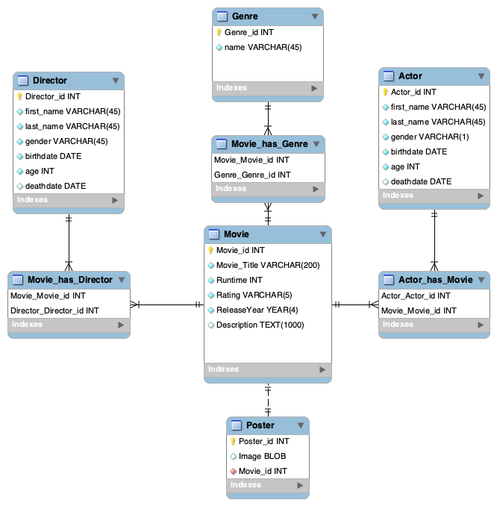ERD

SQL DDL and DML

DDL Commands and Indexes

create table Movie(

Movie_id INT NOT NULL,

Movie_title VARCHAR(200) NOT NULL,

Runtime INT NOT NULL,

Rating VARCHAR(5) NOT NULL,

ReleaseYear YEAR(4) NOT NULL,

Description TEXT(1000),

PRIMARY KEY (Movie_id));

create table Genre(

Genre_id INT NOT NULL,

name VARCHAR(45) NOT NULL,

PRIMARY KEY (Genre_id));

create TABLE Movie_has_Genre(

Movie_Movie_id INT NOT NULL,

Genre_Genre_id INT NOT NULL,

PRIMARY KEY (Movie_Movie_id, Genre_Genre_id),

FOREIGN KEY (Movie_Movie_id) REFERENCES Movie(Movie_id)

ON DELETE CASCADE,

FOREIGN KEY (Genre_Genre_id) REFERENCES Genre(Genre_id));

create TABLE Director(

Director_id INT NOT NULL,

first_name VARCHAR(45) NOT NULL,

last_name VARCHAR(45) NOT NULL,

gender VARCHAR(1) NOT NULL,

birthdate DATE NOT NULL,

PRIMARY KEY (Director_id));

ALTER TABLE Director ADD deathdate DATE NULL;

ALTER TABLE Director ADD CHECK (deathdate > birthdate);

create TABLE Movie_has_Director(

Movie_Movie_id INT NOT NULL,

Director_Director_id INT NOT NULL,

PRIMARY KEY (Movie_Movie_id, Director_Director_id),

FOREIGN KEY (Movie_Movie_id) REFERENCES Movie(Movie_id)

ON DELETE CASCADE

ON UPDATE CASCADE,

FOREIGN KEY (Director_Director_id) REFERENCES Director(Director_id));

create TABLE Actor(

Actor_id INT NOT NULL,

first_name VARCHAR(45) NOT NULL,

last_name VARCHAR(45) NOT NULL,

gender VARCHAR(1) NOT NULL,

birthdate DATE NOT NULL,

PRIMARY KEY (Actor_id));

ALTER TABLE Actor ADD deathdate DATE NULL;

ALTER TABLE Actor ADD CHECK (deathdate > birthdate);

create TABLE Movie_has_Actor(

Movie_Movie_id INT NOT NULL,

Actor_Actor_id INT NOT NULL,

PRIMARY KEY (Movie_Movie_id, Actor_Actor_id),

FOREIGN KEY (Movie_Movie_id) REFERENCES Movie(Movie_id)

ON DELETE CASCADE

ON UPDATE CASCADE,

FOREIGN KEY (Actor_Actor_id) REFERENCES Actor(Actor_id)

);

create TABLE Poster(

Poster_id INT NOT NULL,

Image BLOB NOT NULL,

Movie_Movie_id INT NOT NULL,

PRIMARY KEY (Poster_id),

FOREIGN KEY (Movie_Movie_id) REFERENCES Movie(Movie_id)

ON DELETE CASCADE

);

Indexes

Movies are primarily searched by title and thus title is the clear best option.

CREATE INDEX movie_title

ON Movie(Movie_title);

Actor and director could be indexed by first or last name, but since last name is typically more unique, last name was chosen as the index.

CREATE INDEX actor_name

ON Actor(last_name);

CREATE INDEX director_name

ON Director(last_name);

Genres are only searched by name and thus name is the clear best option.

CREATE INDEX genre_name

ON Genre(name);

Example DML

INSERT INTO Movie VALUES(00001, 'Django Unchained', 165, 'R', 2012, 'With the help of a German bounty hunter, a freed slave sets out to rescue his wife from a brutal Mississippi plantation owner.');

INSERT INTO Actor VALUES(000001, 'Jamie', 'Foxx', 'M', '1967-12-13',null);

INSERT INTO Actor VALUES(000002, 'Christoph', 'Waltz', 'M', '1956-10-04',null);

INSERT INTO Actor VALUES(000003, 'Leonardo', 'DiCaprio', 'M', '1974-11-11',null);

INSERT INTO Actor VALUES(000004, 'Kerry', 'Washington', 'F', '1977-01-31',null);

INSERT INTO Actor VALUES(000005, 'Samuel', 'Jackson', 'M', '1948-12-21',null);

INSERT INTO Movie_has_Actor VALUES(00001, 000001);

INSERT INTO Movie_has_Actor VALUES(00001, 000002);

INSERT INTO Movie_has_Actor VALUES(00001, 000003);

INSERT INTO Movie_has_Actor VALUES(00001, 000004);

INSERT INTO Movie_has_Actor VALUES(00001, 000005);

INSERT INTO Director VALUES(00001, 'Quentin', 'Tarantino', 'M', '1963-03-27',null);

INSERT INTO Movie_has_Director VALUES(00001, 00001);

INSERT INTO Genre VALUES(001, 'Western');

INSERT INTO Genre VALUES(002, 'Drama');

INSERT INTO Genre VALUES(003, 'Action');

INSERT INTO Movie_has_Genre VALUES(00001, 001);

INSERT INTO Movie_has_Genre VALUES(00001, 002);

INSERT INTO Movie_has_Genre VALUES(00001, 003);

DML generated in php

**Search by title**

SELECT Movie_ID, Movie_title, Runtime, Rating, ReleaseYear FROM Movie WHERE Movie_title LIKE '$searchq%' AND Rating in $ratq AND ReleaseYear $yearIneq $yearq AND Runtime $lenIneq $lenq ORDER BY Movie_title;

**Search by Actor**

Select Movie_title, runtime, rating, releaseYear, CONCAT(first_name, ' ', last_name) as actor, gender, DATE_FORMAT(birthdate, '%b %e, %Y') as birthdate,

CASE

WHEN deathdate IS null THEN FLOOR(datediff(current_date, birthdate) / 365.25 )

ELSE FLOOR(datediff(deathdate, birthdate) / 365.25 )

END AS age

from Movie join Movie_has_Actor MhA on Movie.Movie_id = MhA.Movie_Movie_id join Actor A on A.Actor_id = MhA.Actor_Actor_id

WHERE (last_name LIKE '$searchq%' OR first_name LIKE '$searchq%' OR CONCAT(first_name, ' ', last_name) LIKE '$searchq%') AND gender in $genderq AND birthdate $yearIneq $yearq ORDER BY last_name;

**Search by Director**

Select Movie_title, runtime, rating, releaseYear, CONCAT(first_name, ' ', last_name) as director, gender, DATE_FORMAT(birthdate, '%b %e, %Y') as birthdate,

CASE

WHEN deathdate IS null THEN FLOOR(datediff(current_date, birthdate) / 365.25 )

ELSE FLOOR(datediff(deathdate, birthdate) / 365.25 )

END AS age

from Director join Movie_has_Director MhD on Director.Director_id = MhD.Director_Director_id join Movie M on M.Movie_id = MhD.Movie_Movie_id

WHERE (last_name LIKE '$searchq%' OR first_name LIKE '$searchq%' OR CONCAT(first_name, ' ', last_name) LIKE '$searchq%') AND gender in $genderq AND birthdate $yearIneq $yearq ORDER BY last_name;

**Search by Genre**

SELECT Movie_title, Runtime, Rating, ReleaseYear, name as genre FROM Movie join Movie_has_Genre MhG on Movie.Movie_id = MhG.Movie_Movie_id join Genre G on G.Genre_id = MhG.Genre_Genre_id WHERE name LIKE '$searchq%' AND Rating in $ratq AND ReleaseYear $yearIneq $yearq AND Runtime $lenIneq $lenq ORDER BY genre"

**Insertion Commands:**

**Movie**

INSERT INTO Movie (Movie_id, Movie_title, Runtime, Rating, ReleaseYear, Description) VALUES (?, ?, ?, ?, ?, ?)");

bind_param("isisis", $mid, $title, $runTime, $rating, $year, $desc);

**Genre**

$gN = count($genre_names);

for($i=0; $i < ($gN) ; $i++) {

if($gname[$i] == ''){

$gname[$i] = null;

}

CALL checkIfGenreExists(?);

bind_param("s", $gname[$i]);

bind_result($id_out)

$returngid = $id_out;

if($returngid != '-1'){

$gid[$i] = $returngid;

} else {

INSERT INTO Genre (Genre_id, name) VALUES (?, ?);

bind_param("is", $gid[$i], $gname[$i]);

}

Insert INTO Movie_has_Genre (Movie_Movie_id, Genre_Genre_id) VALUES (?, ?);

bind_param("ii", $mid, $gid[$i]);

}

**Director**

$dN = count($director_lastnames);

for($i=0; $i < ($dN) ; $i++){

CALL checkIfDirectorExists(?, ?, ?);

bind_param("sss", $dfn[$i], $dln[$i], $dbdate[$i]);

bind_result($id_out)

$returndid = $id_out;

if($returndid != '-1'){

$did[$i] = $returndid;

} else {

INSERT INTO Director (Director_id, first_name, last_name, gender, birthdate, deathdate) VALUES (?, ?, ?, ?, ?, null);

bind_param("issss", $did[$i], $dfn[$i], $dln[$i], $dgender[$i], $dbdate[$i]);

}

INSERT INTO Movie_has_Director (Movie_Movie_id, Director_Director_id)VALUES (?, ?);

bind_param("ii", $mid, $did[$i]);

}

**Actor**

$aN = count($actor_lastnames);

for($i=0; $i < ($aN) ; $i++){

CALL checkIfActorExists(?, ?, ?);

bind_param("sss", $afn[$i], $aln[$i], $abdate[$i]);

bind_result($id_out);

$returnaid = $id_out;

if($returnaid != '-1'){

$aid[$i] = $returnaid;

} else {

INSERT INTO Actor (Actor_id, first_name, last_name, gender, birthdate, deathdate) VALUES (?, ?, ?, ?, ?, null);

bind_param("issss", $aid[$i], $afn[$i], $aln[$i], $agender[$i], $abdate[$i]);

}

INSERT INTO Movie_has_Actor (Movie_Movie_id, Actor_Actor_id) VALUES (?, ?);

bind_param("ii", $mid, $aid[$i]);

}

**Delete**

DELETE FROM Movie WHERE Movie_ID = $id;

**Update**

if($date == ''){

UPDATE Director set deathdate = null WHERE Director_id = $id;

} else {

UPDATE Director set deathdate = '$date' WHERE Director_id = $id;

}

if($date == ''){

UPDATE Actor set deathdate = null WHERE Actor_id = $id;

} else {

UPDATE Actor set deathdate = '$date' WHERE Actor_id = $id;

}

**Poster**

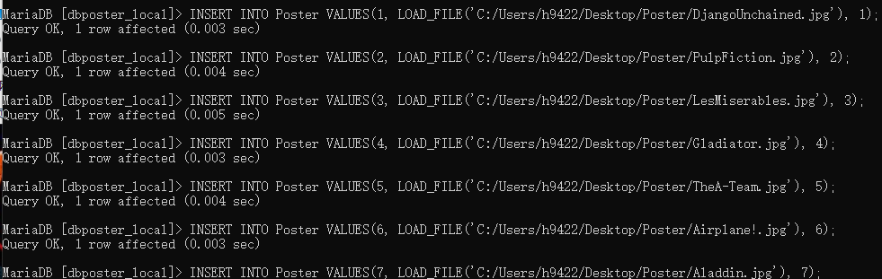

SQL Views

CREATE VIEW movieActors as

Select Actor_id, first_name, last_name, gender, birthdate,

CASE

WHEN deathdate IS null THEN

FLOOR(datediff(current_date, birthdate) / 365.25 )

ELSE FLOOR(datediff(deathdate, birthdate) / 365.25 )

END AS age, deathdate, Movie_id, Movie_title, Runtime, Rating, ReleaseYear, Description

from Actor join Movie_has_Actor MhA on Actor.Actor_id = MhA.Actor_Actor_id join Movie M on M.Movie_id = MhA.Movie_Movie_id;

CREATE VIEW movieDirectors as Select Director_id, first_name, last_name, gender, birthdate,

CASE

WHEN deathdate IS null THEN

FLOOR(datediff(current_date, birthdate) / 365.25 )

ELSE FLOOR(datediff(deathdate, birthdate) / 365.25 )

END AS age, deathdate, Movie_id, Movie_title, Runtime, Rating, ReleaseYear, Description

from Director join Movie_has_Director MhD on Director.Director_id = MhD.Director_Director_id join Movie M on M.Movie_id = MhD.Movie_Movie_id;

Create VIEW movieGenres as Select Genre_id, name, Movie_id, Movie_title, Runtime, Rating, ReleaseYear, Description

from Genre join Movie_has_Genre MhG on Genre.Genre_id = MhG.Genre_Genre_id join Movie M on M.Movie_id = MhG.Movie_Movie_id;

SQL Procedures

Procedures check if a record exists in the given entity and returns the id of the record if it exists and returns -1 if not.

DELIMITER $$

USE team2_db $$

CREATE PROCEDURE *checkIfGenreExists*(IN genreName VARCHAR(45))

BEGIN

IF exists(select name from Genre where name = genreName) THEN

Select Genre_id as genreID from Genre where name = genreName;

ELSE

Select -1 as genreID;

end if;

END $$ DELIMITER;

DELIMITER $$

USE team2_db $$

CREATE PROCEDURE *checkIfActorExists*(IN actor_fName VARCHAR(45), IN actor_lName VARCHAR(45), IN actor_date DATE)

BEGIN

IF exists(select * from Actor where last_name = actor_lname AND first_name = actor_fname AND birthdate = actor_date) THEN

Select Actor_id as actorID from Actor where last_name = actor_lname AND first_name = actor_fname AND birthdate = actor_date;

ELSE

Select -1 as actorID;

end if;

END $$

DELIMITER;

DELIMITER $$

USE team2_db $$

CREATE PROCEDURE *checkIfDirectorExists*(IN director_fName VARCHAR(45), IN director_lName VARCHAR(45), IN director_date DATE)

BEGIN

IF exists(select * from Director where last_name = director_lname AND first_name = director_fname AND birthdate = director_date) THEN

Select Director_id as directorID from Director where last_name = director_lname AND first_name = director_fname AND birthdate = director_date;

ELSE

Select -1 as directorID;

end if;

END $$ DELIMITER;

DELIMITER $$

USE team2_db $$

CREATE PROCEDURE *checkIfMovieExists*(IN title VARCHAR(200), IN rt INT, IN releaseYr INT)

BEGIN

IF exists(Select * from Movie Where Movie_title = title AND runtime = rt AND ReleaseYear = releaseYr) THEN

Select Movie_id as movieID from Movie Where Movie_title = title AND runtime = rt AND ReleaseYear = releaseYr;

ELSE

Select -1 as movieID;

end if;

END $$

DELIMITER;

How application will be used

This application will primarily be used by individual users on small scale movie collections, and thus data integrity and accuracy are not of high importance and are the responsibility of the given user. Also, since it is a *movie* interface, its sole function is searching for movies and all other entities are supplemental. Thus, we decided to only implement search functionality for movies. The search functionality is the primary feature and thus care was given to ensure its speed, ease of use, and user control over what attributes to search by. This includes an autocomplete feature in the search bar as well as indexing by title, and extensive search controls. Since the primary records are movies, they are the only things with a delete form. If a user loses, or no longer wants the movie appearing in search results it must be deleted. However, since the other entities are effectively multivalued attributes of movies, they do not have dedicated delete forms, but are handled by cascading delete into relationship entities. Actors and directors on occasion will require updating when they have died and thus a form was created for this express purpose. However, updates to movies and other entities require deletion and reinsertion since this should be an uncommon practice. The add page also remains in the spirit of primarily being on a movie basis with all other inserts being attributes. Thus, there is no dedicated actor/director or genre add form, as such actions are always accompanied by a movie.

Interface

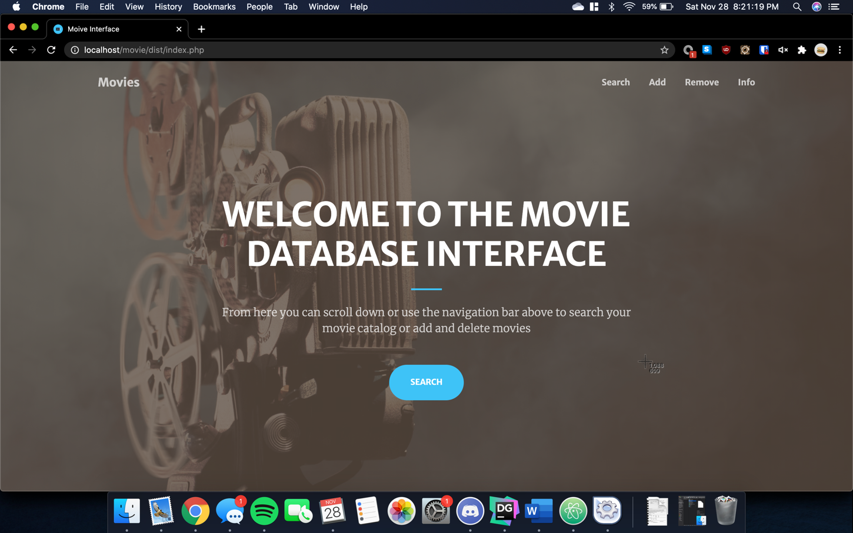

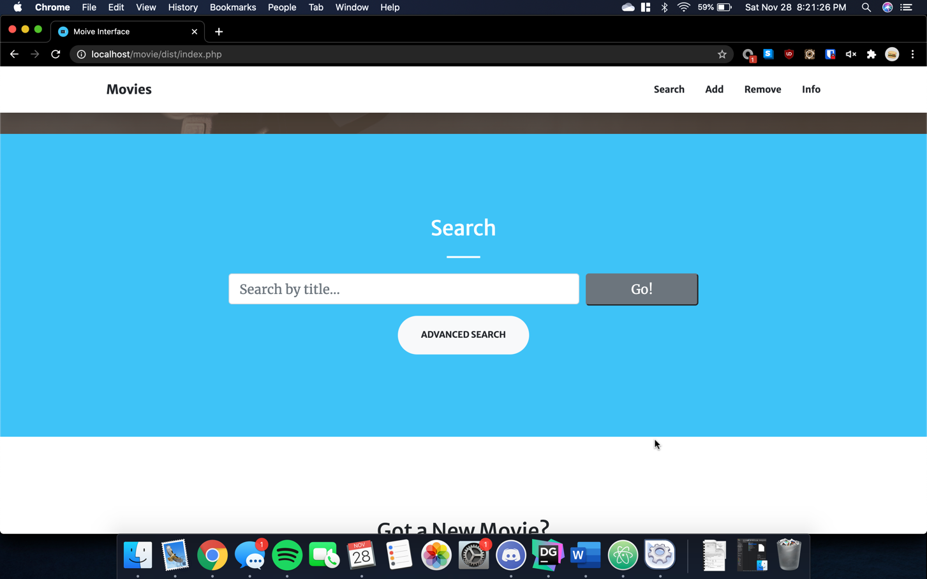

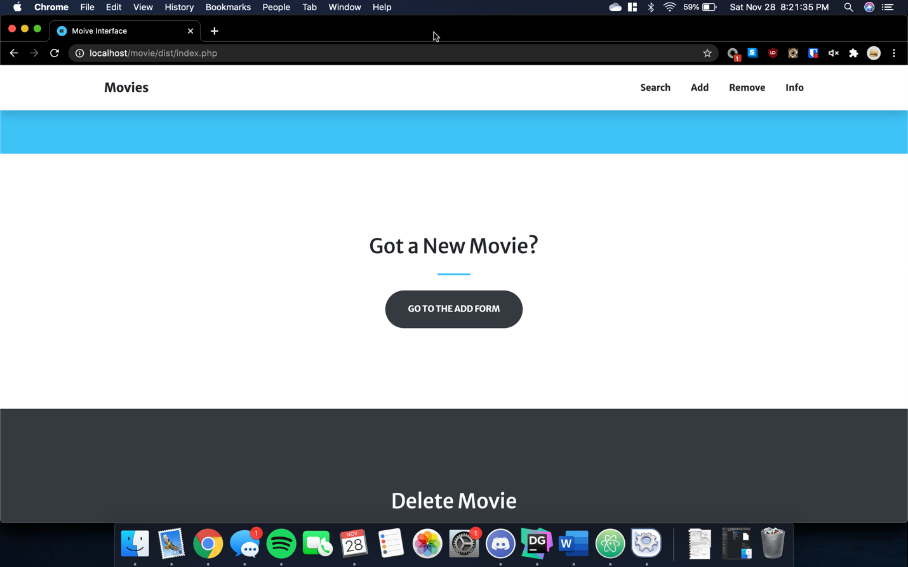

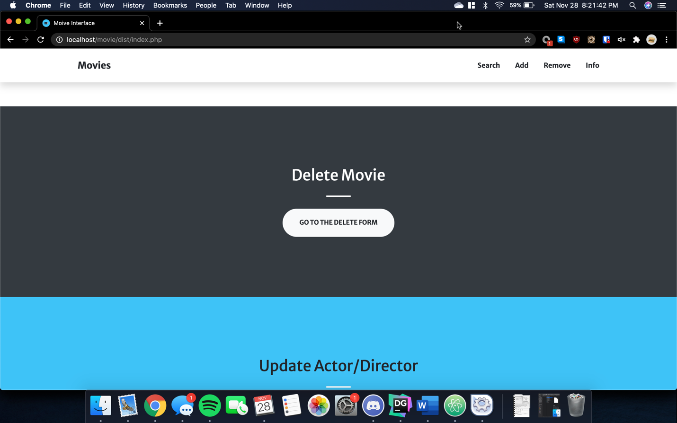

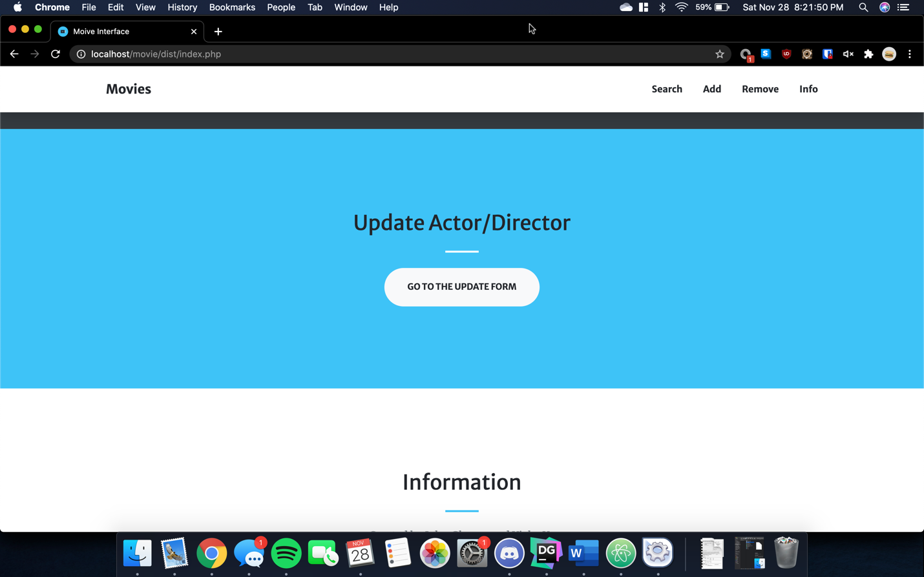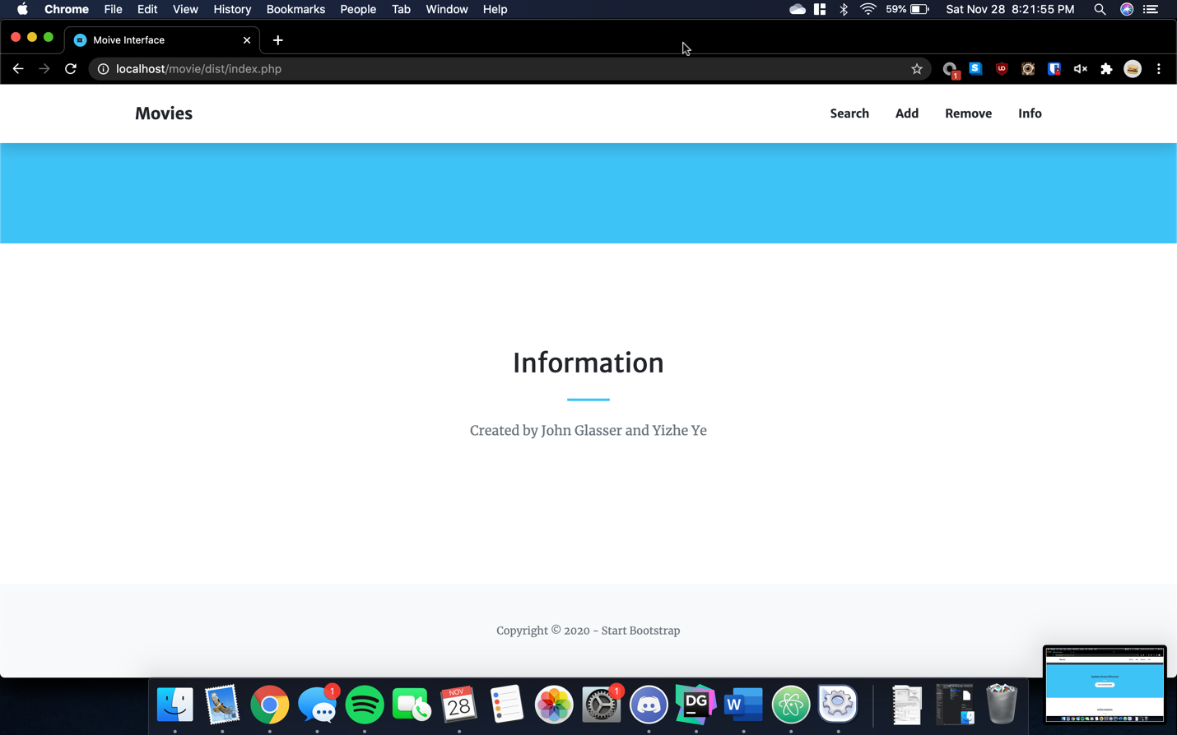

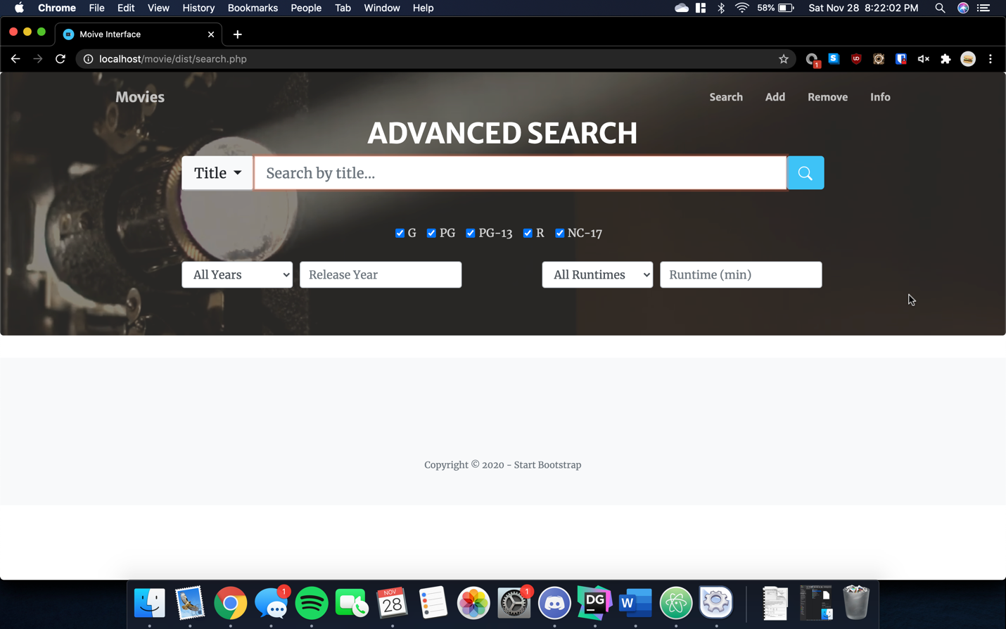

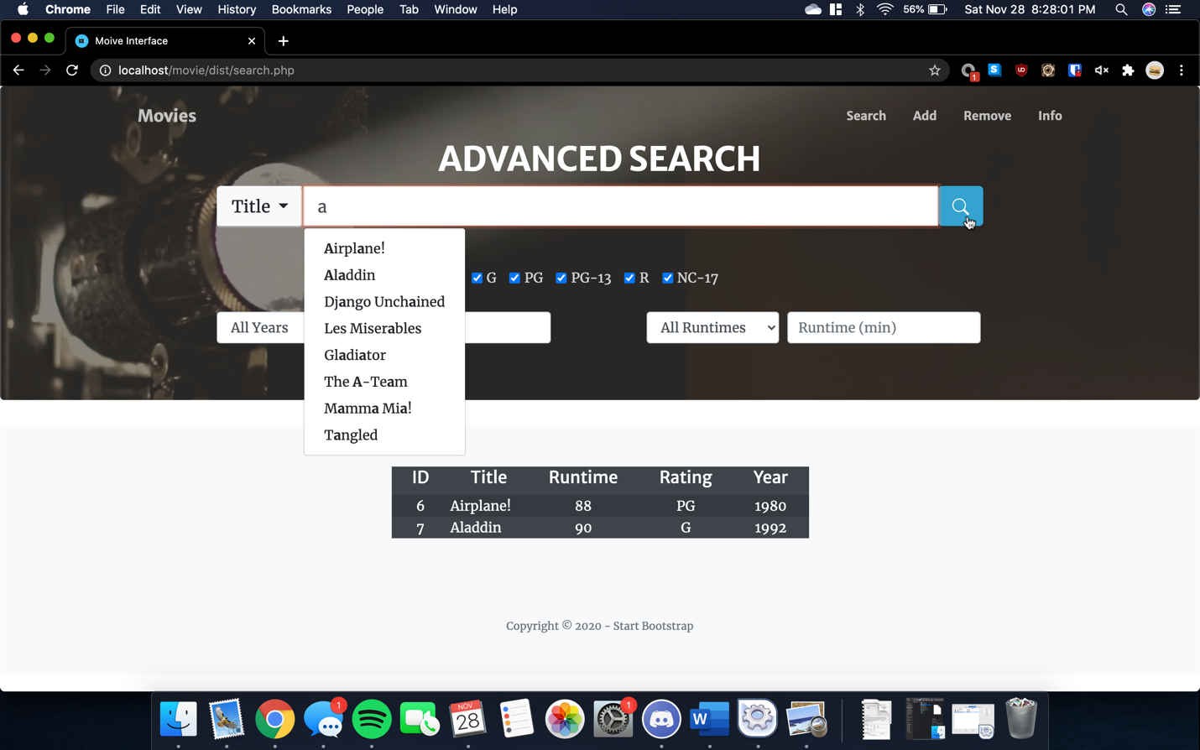

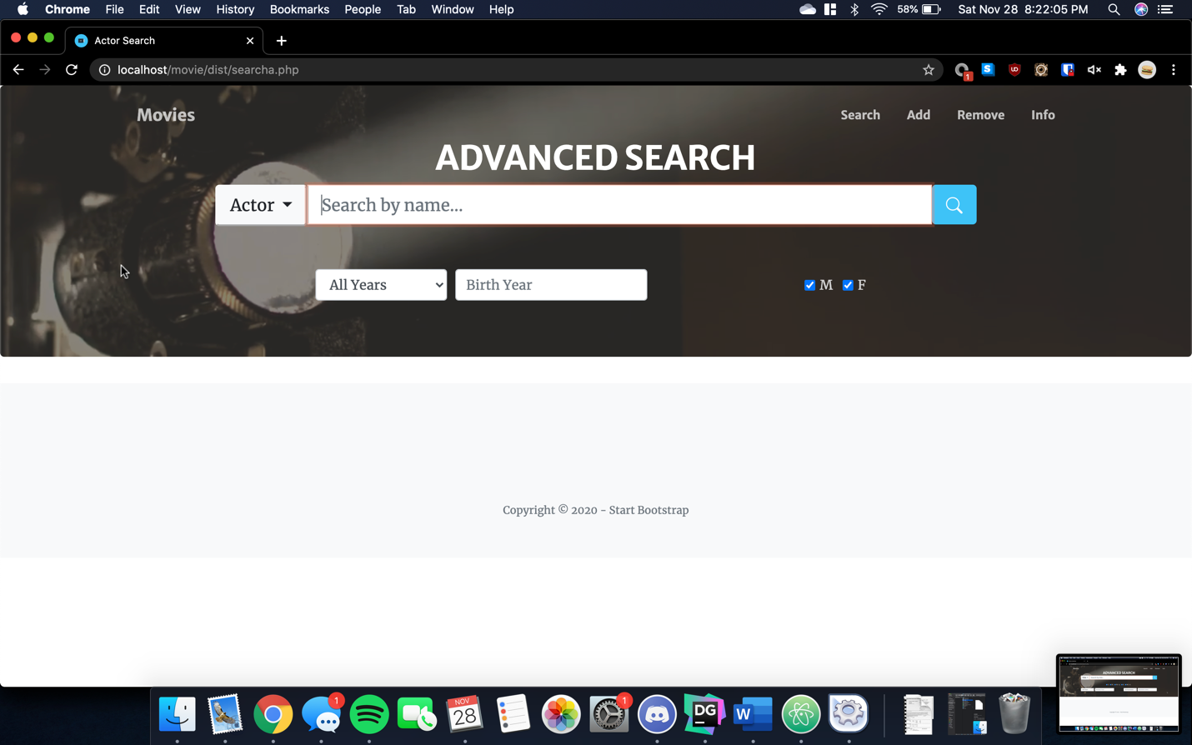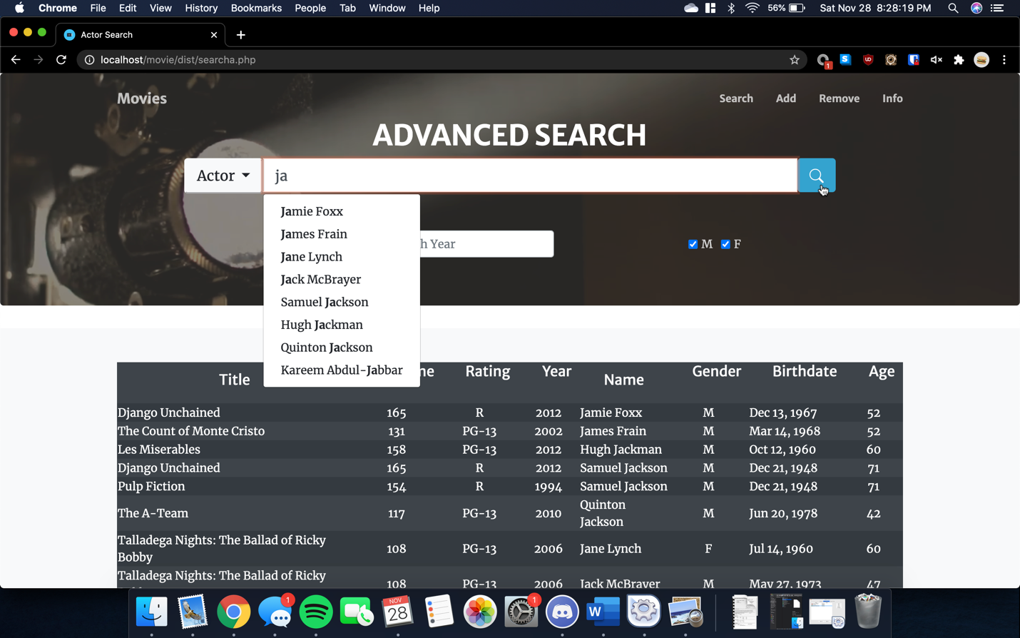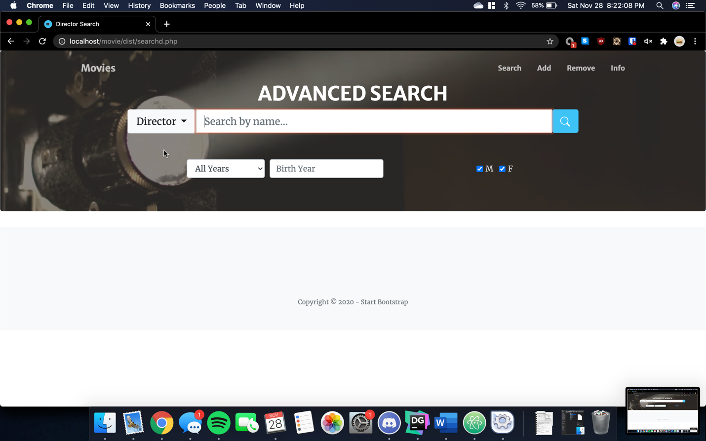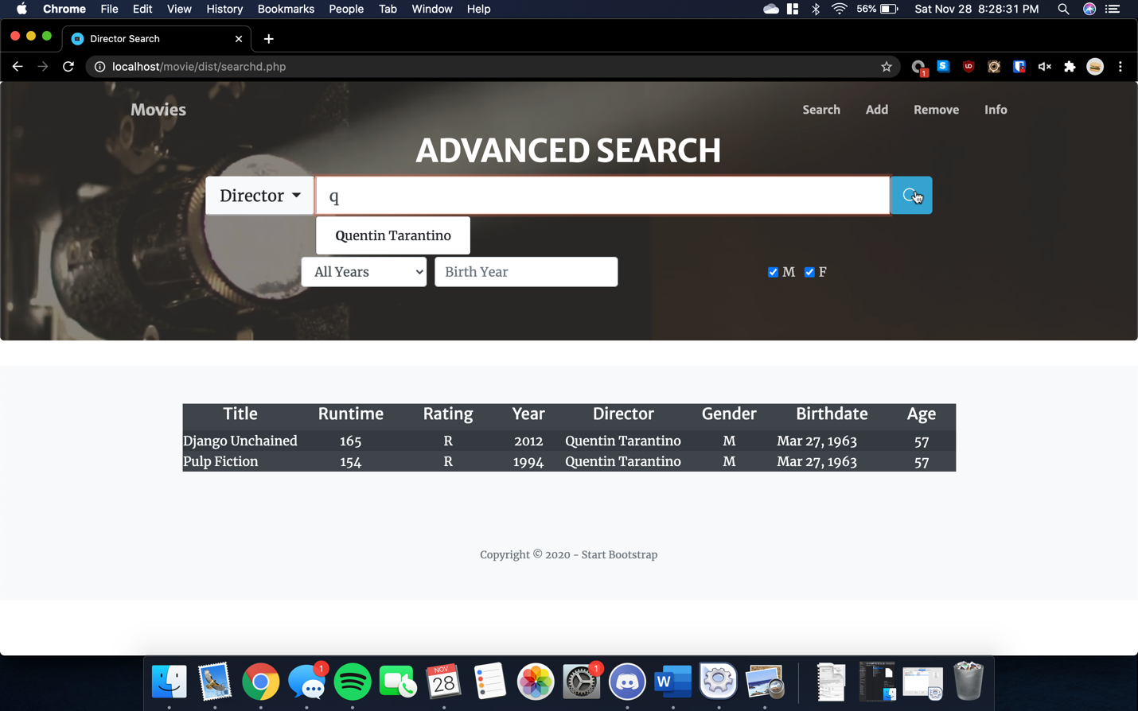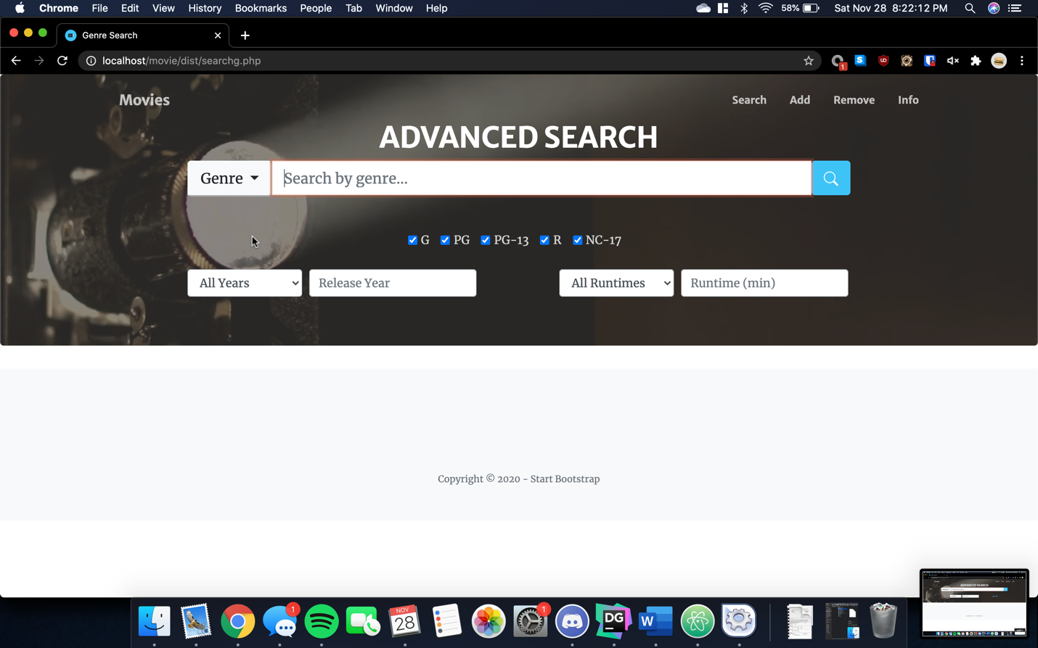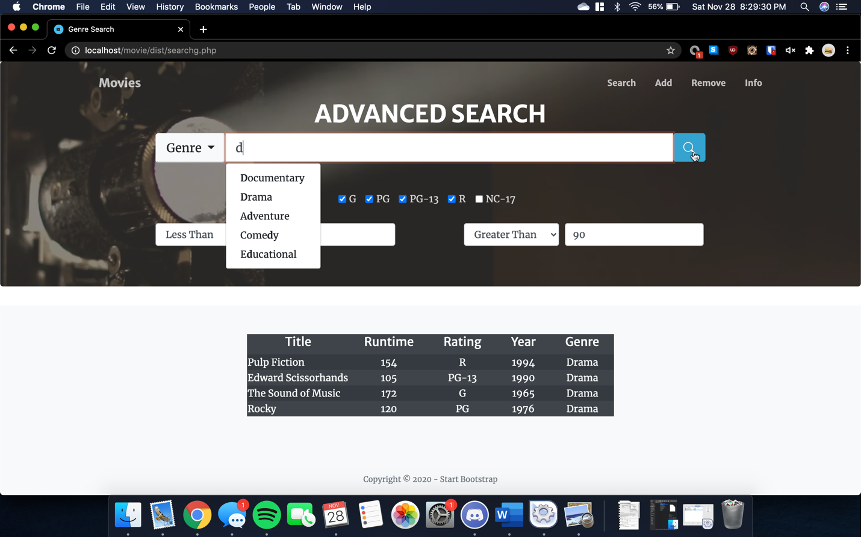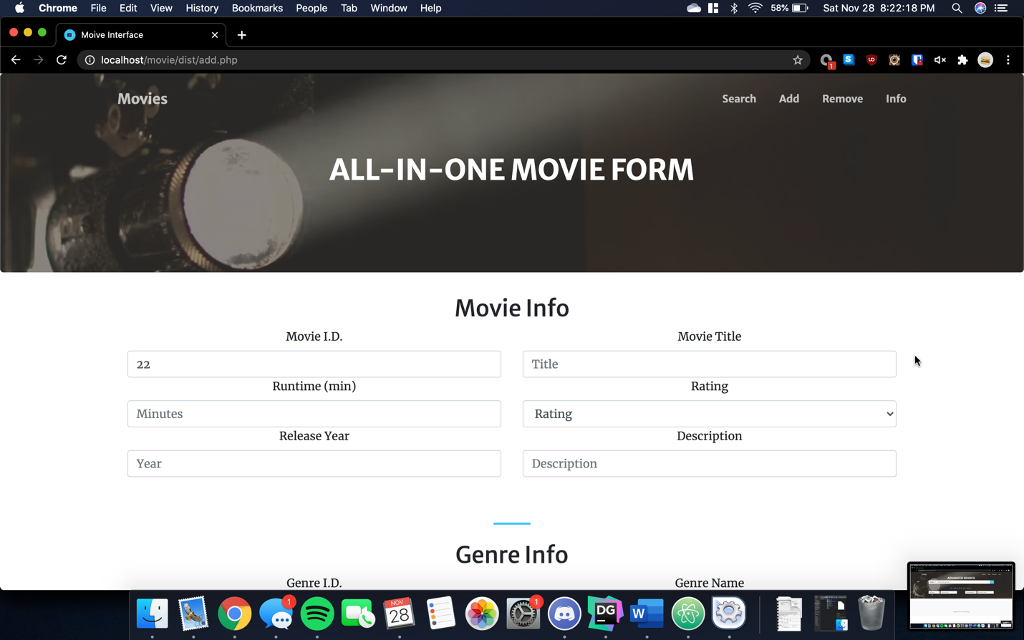

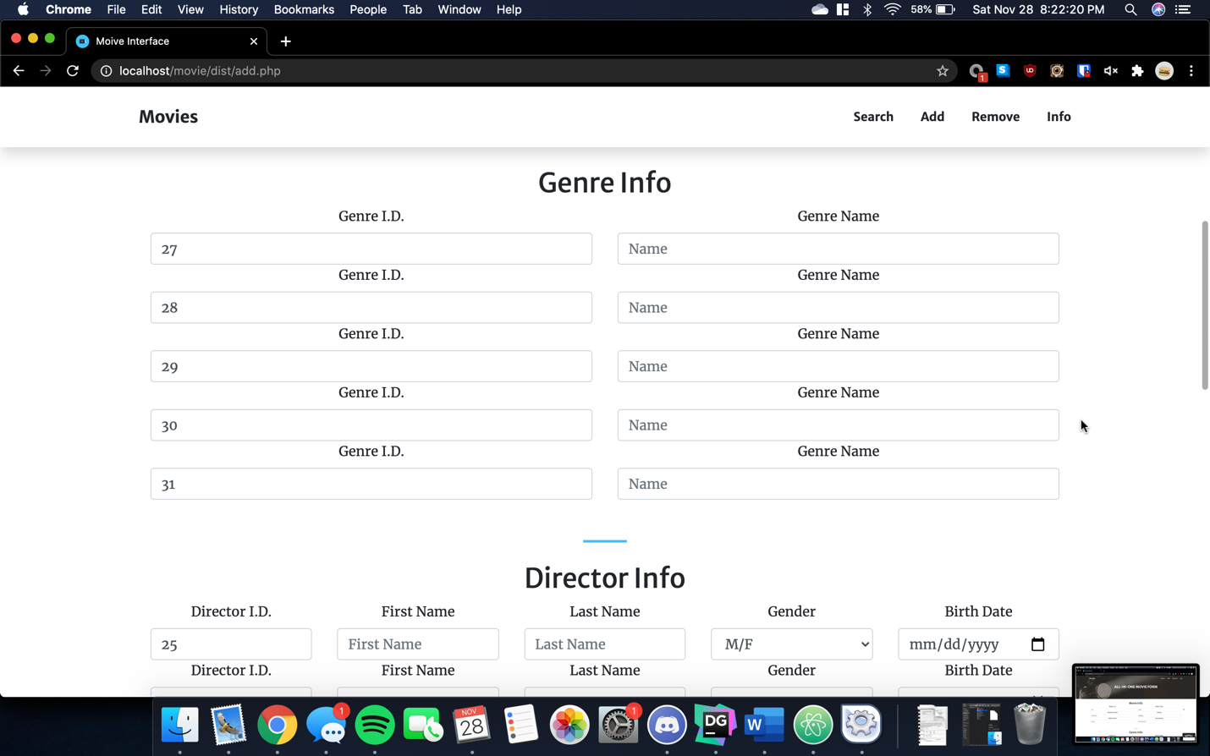

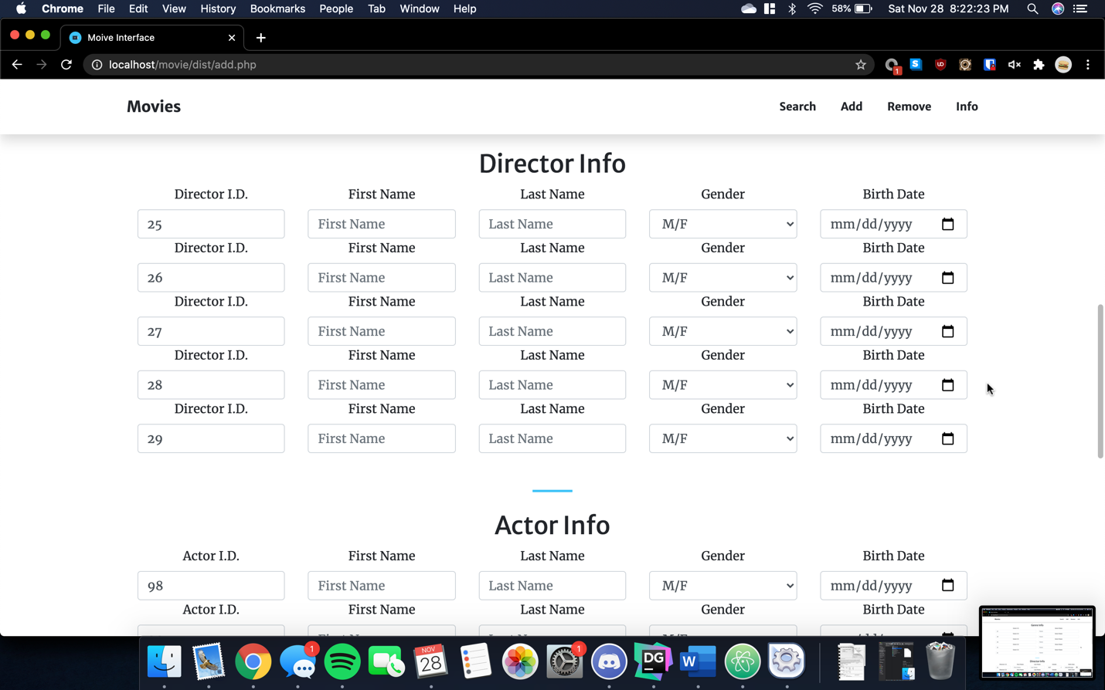

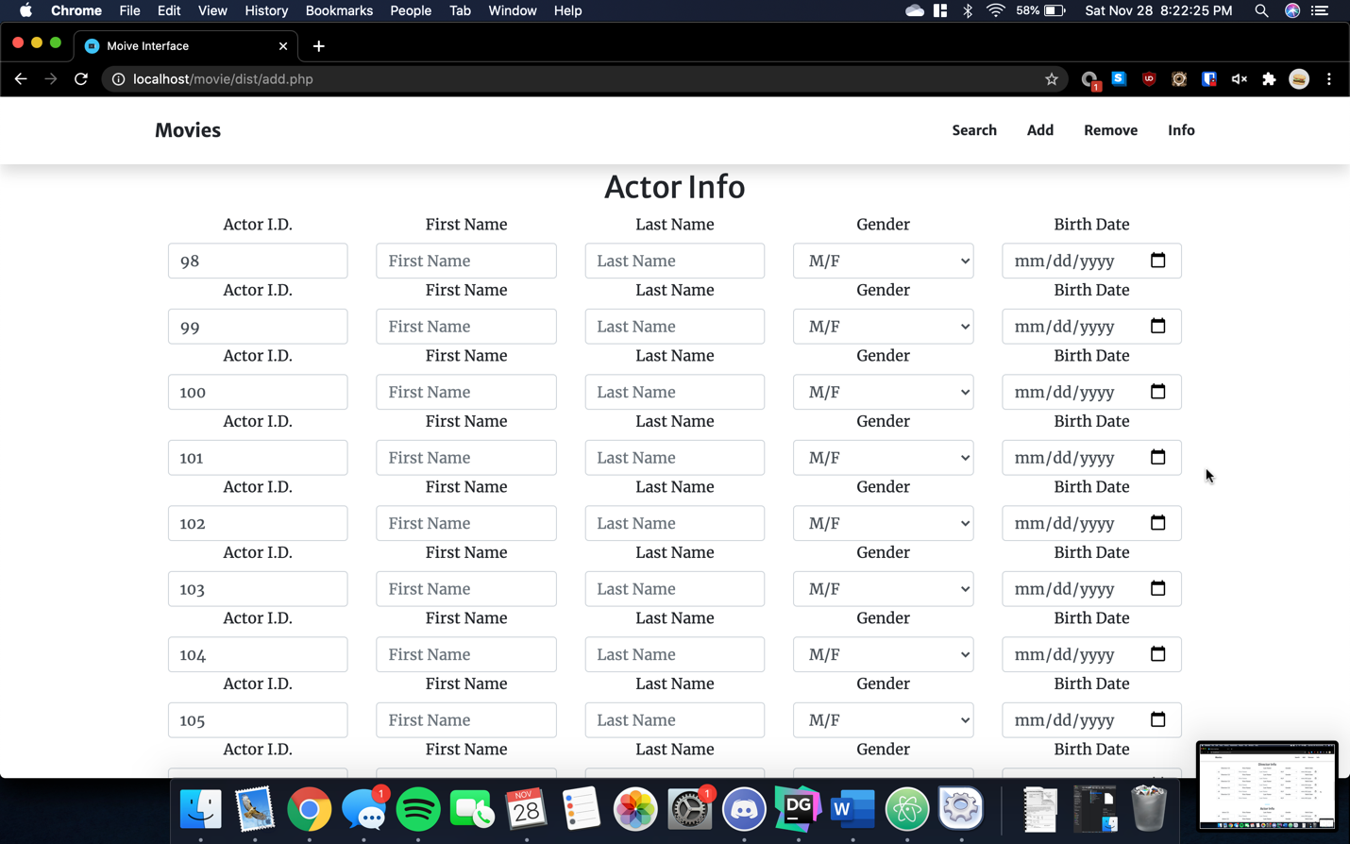

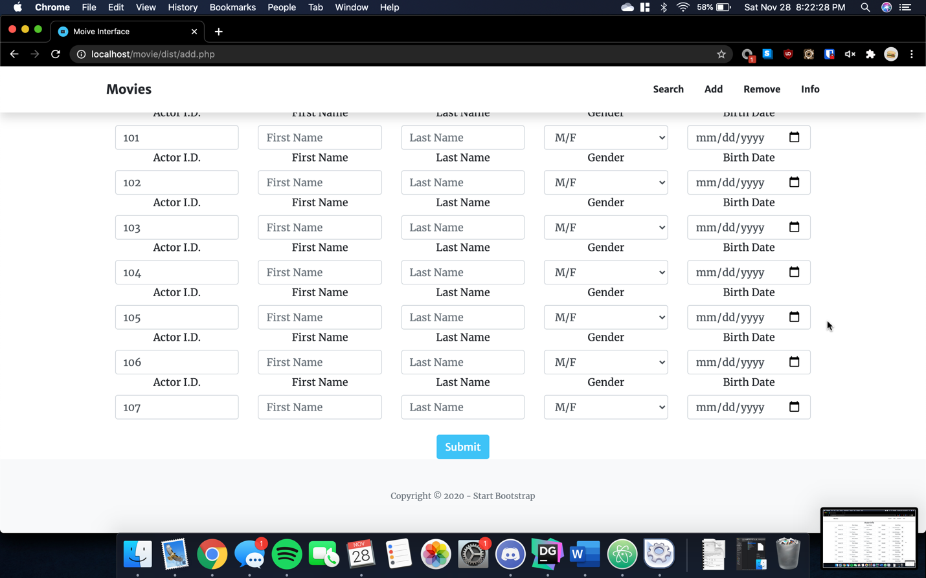

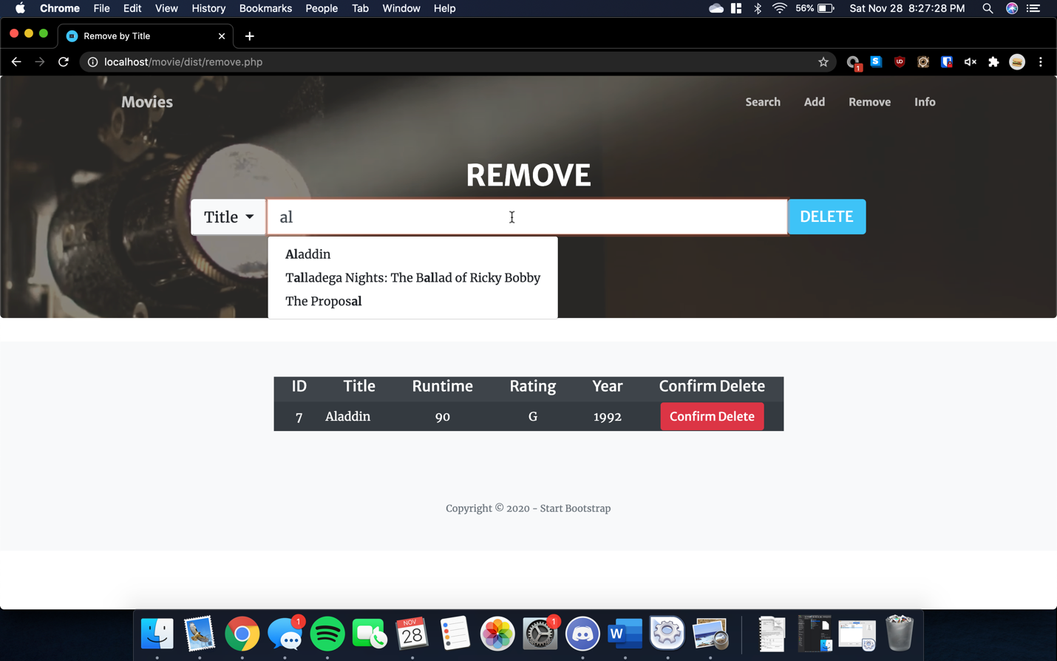

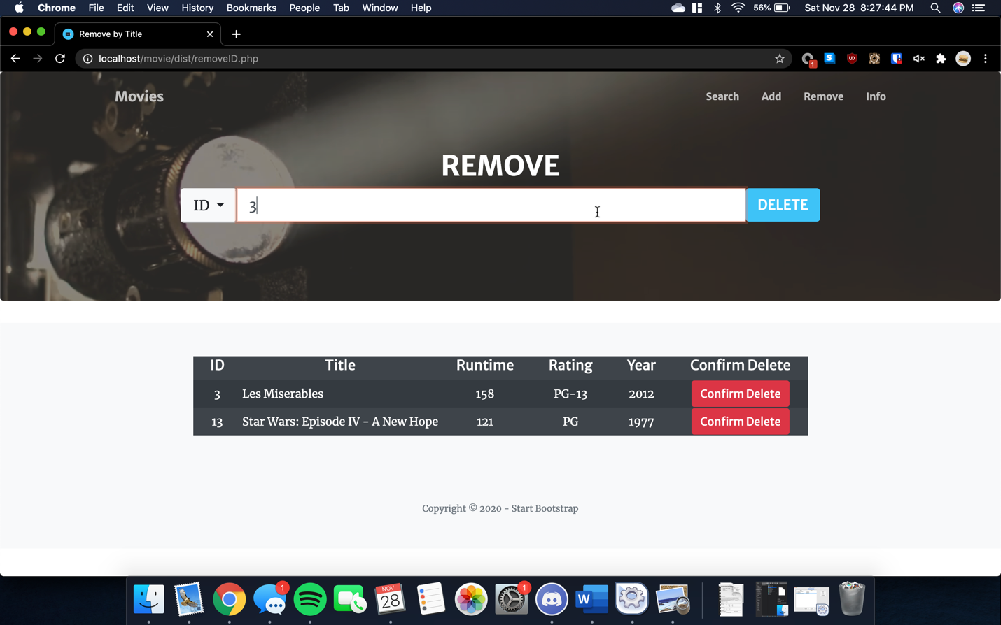

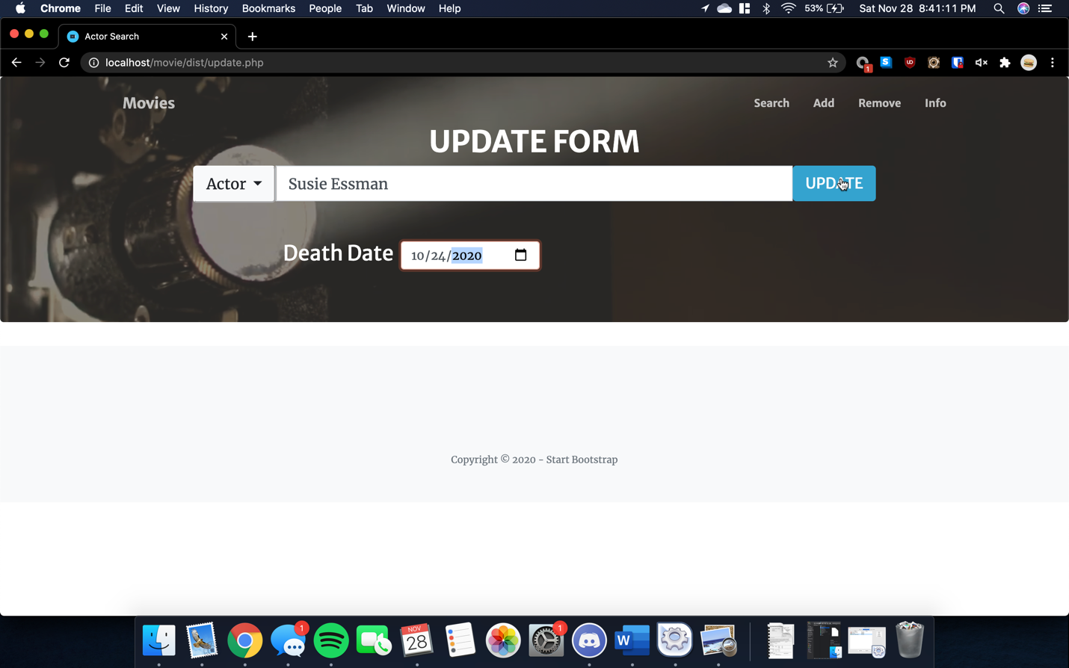

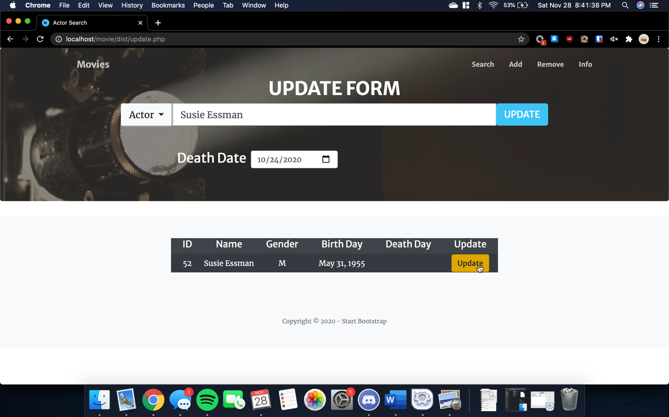

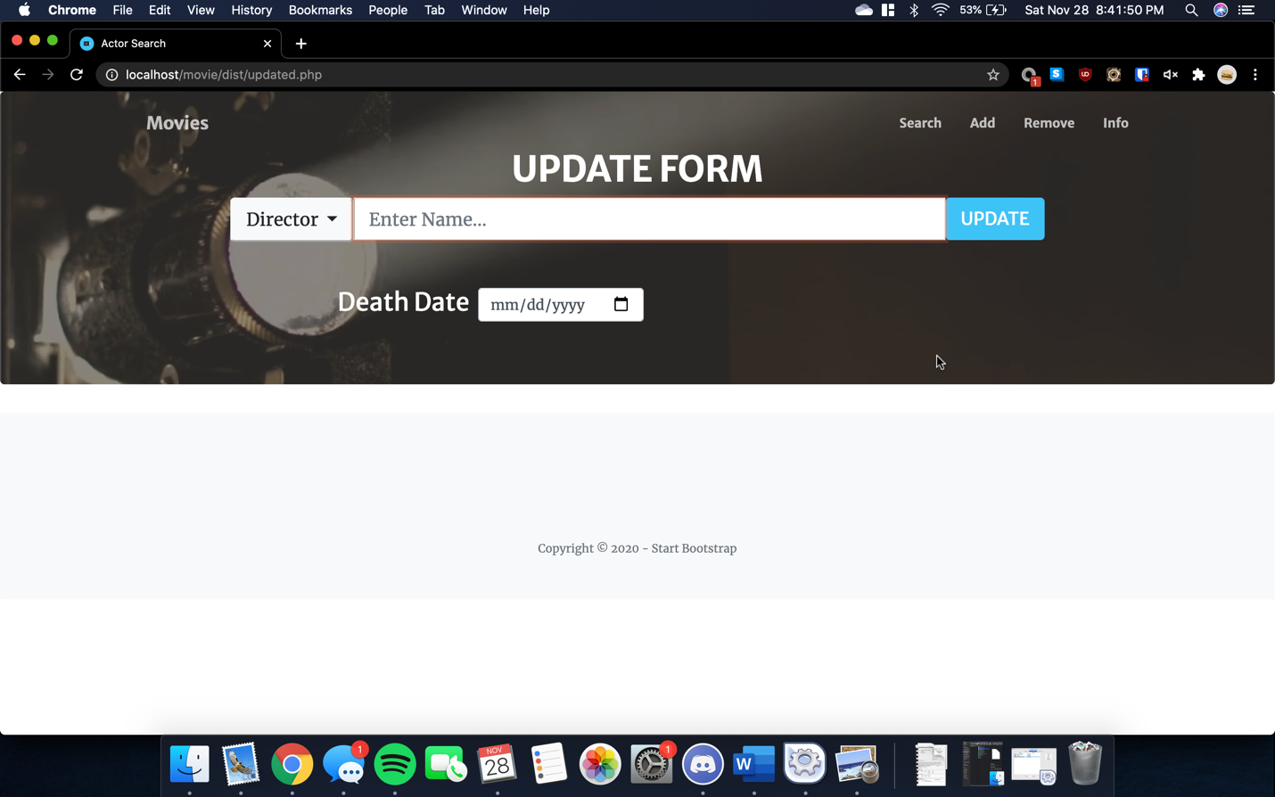

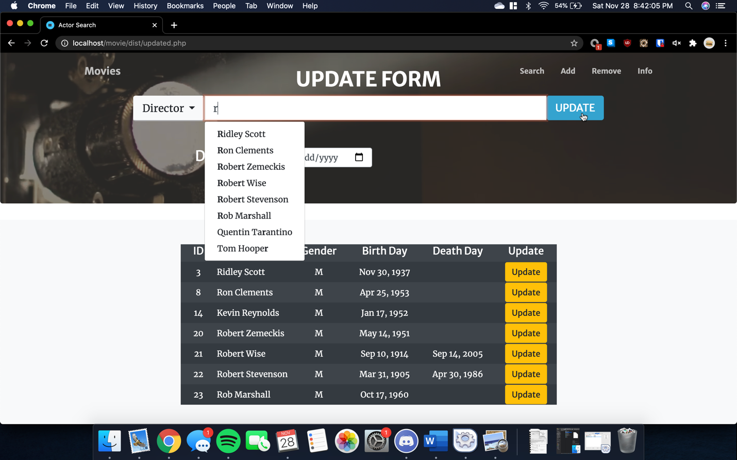

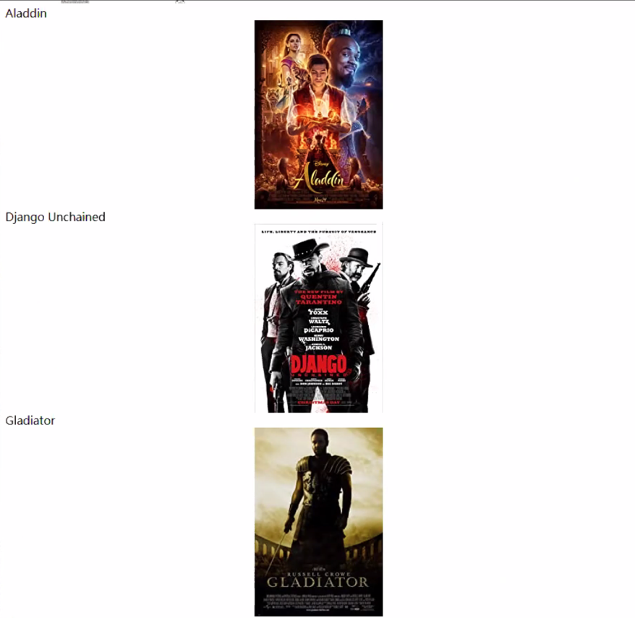

Constraints

Check is used in actor and director to ensure death date is always after birth date. Otherwise all constraints are implemented on the front-end interface. These include: limiting gender values to F and M, limiting rating values to G, PG, PG-13, R, and NC-17, and ensuring there are no repeated actors, directors, and genres.

Integrity

Maintaining referential integrity is maintained solely by foreign key declarations in DDL as id cannot be updated through the interface. Delete on cascade is used to remove records from relationship entities. Update on cascade is implemented for command line queries, but this does not affect interface.

Updates

Expanding database purpose to including searching of all entities would drastically increase the scope of the project. New search, delete, add, and update forms would be required, effectively quadrupling the current size of the project. There are many features to the interface that could not be implemented due to lack of time and web design experience. The major one is implementing java script into the add form to allow a variable number of genres, actors, and directors. This feature would be challenging to implement but would significantly improve the appearance of the form and would remove the arbitrary restrictions on number of genres, actors, and directors allowed per movie. Enabling users to add movies just by title and release year through web scraping script would also be a significant improvement and would require further SQL DDL transactions. Such a script was composed to assist with inserting test data, but implementing into the interface was infeasible.

Error Checking

The forms were designed to prevent non-sensical data. For example, release years are limited to between 1700-current year, runtimes must be greater than 0, gender and rating inputs are drop downs with only valid options, and dates cannot be after the current date. Otherwise, users are free to insert incorrect data since the database is for personal use. What inputs the database can detect are prevented such as death date before birthdate, however, due to the nature of the material, such checks on many attributes are not possible.

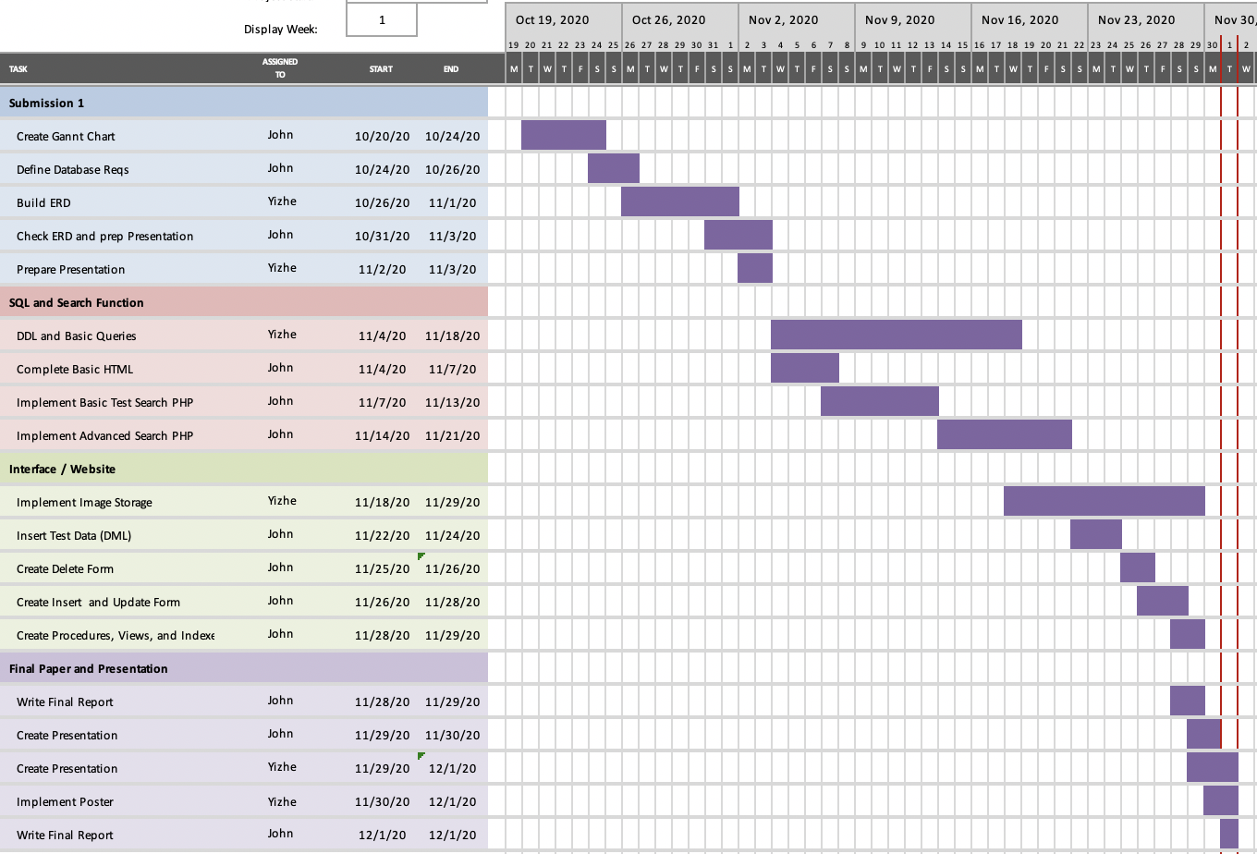Work Distributions

John : 85%

Yizhe: 15%

Github Link

https://github.com/JGlass25/MovieDatabaseProject